***My Tamagotchi Petworld Report***

* *Purpose Of My App*

My Tamagotchi Petworld app is a game that allows users to pet and take care of a dog. The app is designed for users to be able to feed, bath and play with the dog. It also displays the hunger levels, cleanliness levels and mood levels with zero as the minimum and ten as the maximum level of the pet's health. This is to guide the user on when to feed, bath or play with the pet. Overtime the levels will drop and the user will have to feed, bath or play with the dog depending on what it needs the most.

* *Welcome Page*

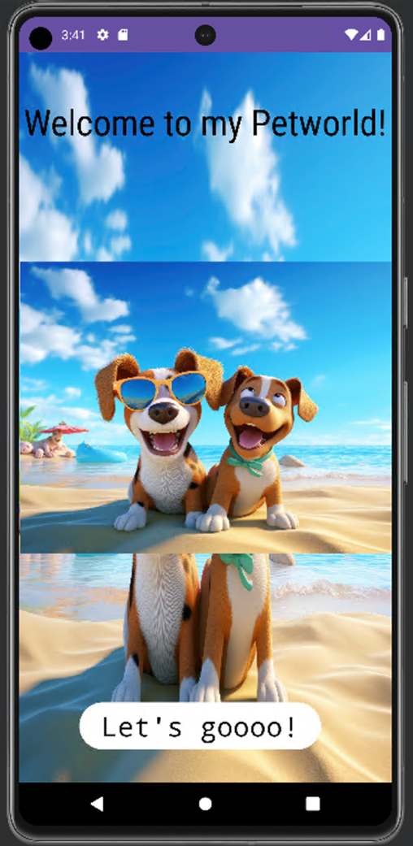FIGURE 1

I created my welcome page to the Petworld using one picture that I got from a website (AI, 2024). Firstly, I set it as a background picture then an image view on top of the background. I used a text view to display the welcome message and used sans-serif-condensed font to make it stand out and catch the user's attention.

To start playing the game, the user has to click the white Let's goooo button that will take them to the actual game.

* *The Actual Game- Second Page*

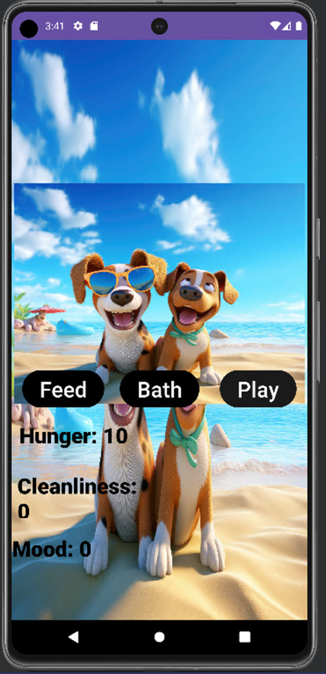FIGURE 2

After clicking the Let's goooo button the user will automatically be directed to the actual game. On this page I implemented three buttons to carry out the actions of caring for the dog. To state the obvious the three buttons carry out actions that match the name of the button for example to feed the pet the user has to click the feed button. The three text views Hunger, Cleanliness and Mood are for displaying levels of how healthy the dog is. The second page begins with the dog being unhealthy.

* *Feeding The Dog*

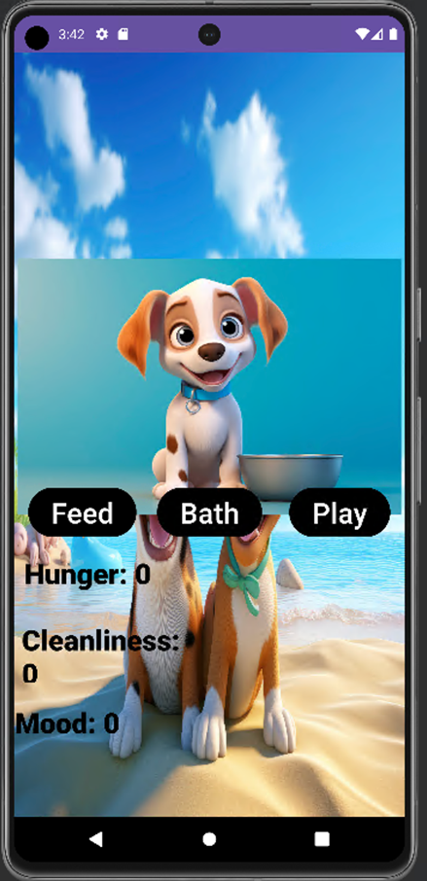FIGURE 3

The first time the user clicks the feed button, the image of a dog with a bowl next to it will appear to match the action of the button (AI, 2024). The level of hunger will go from ten to 0 because it was set to decrease by one each time the dog is fed. To feed the dog until it is full the user needs to click the feed button ten times.

* 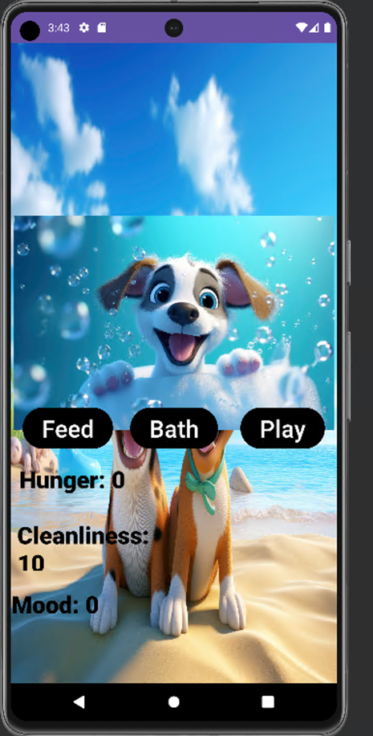*Bathing The Dog*

FIGURE 4

To bath the dog, the user needs to click the bath button in the middle. Just like the feed button, the bath button also changes the image view of the app to a dog in a bathtub to match the action of the button (AI, 2024). The pet is only completely clean after the cleanliness button has been clicked ten times and the cleanliness level shows that it is at ten just like above.

* *Playing With The Pet*

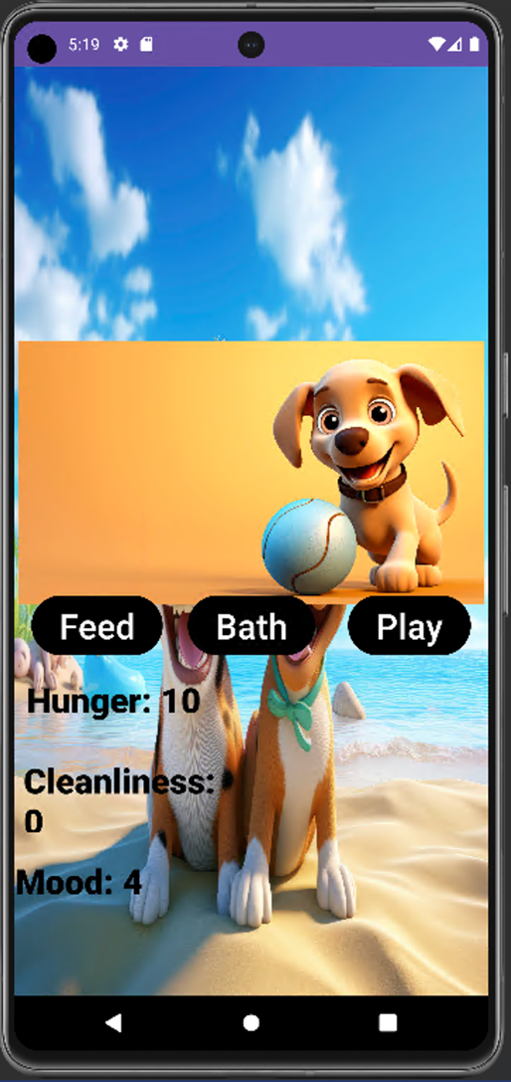FIGURE 5

To keep the mood levels of the pet high the user uses the Play button. Upon clicking it, the image will instantly change to a picture of a dog playing with a ball and immediately the level will increment by 1 (AI, 2024). In the screenshot above you can tell that the mood level of the dog is at four which is low. The highest the dog's mood can go is ten so the user will have to click it six more times to keep the dog happy.

* *A Healthy Pet*

FIGURE 6

Above is an illustration of what a healthy pet looks like. The image of the dog playing and the mood level of ten shows that the pet just finished playing and has reached its maximum play time for that certain period.

The cleanliness level is at 10 which proves that the dog has been bathed and is clean. The hunger levels are also down to the minimum which shows that the dog is not hungry at all. So overall the pet is healthy and the levels guide the user on when to stop or start caring for the dog.

* *An Unhealthy Pet*

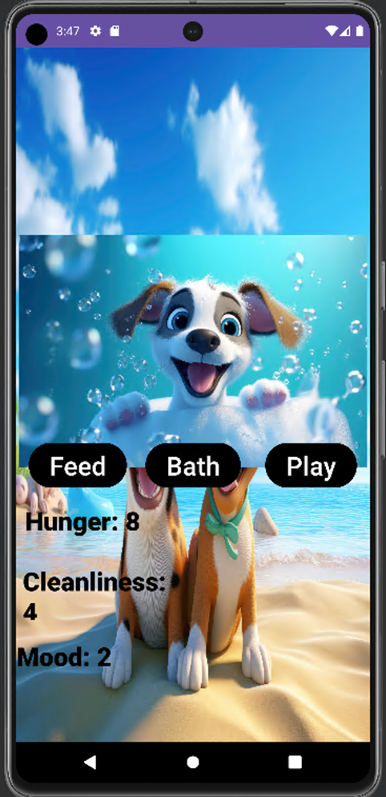FIGURE 7

Above is an example of how an unhealthy pet looks like. The hunger level is high, the bathing image is displayed so the dog has just been washed but it is not clean enough since the cleanliness is at four and the mood is at two meaning the dog has not played enough.

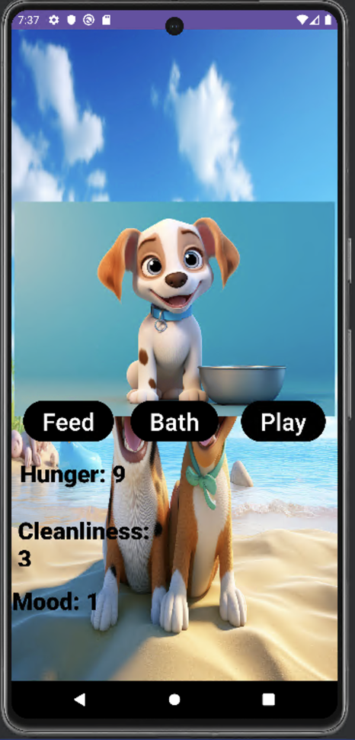FIGURE 8

The status or the levels of the pet's health have been set to change overtime. Every 22 000 milliseconds the hunger level will go up by one, the cleanliness goes down by 1 and the mood also decreases by one.

# Image Reference List

AI, 2024. *FREEP!K.* [Online]   
Available at: https://www.freepik.com/free-ai-image/3d-rendering-cartoon-dog-portrait_149762665.htm  
[Accessed 05 May 2024].

AI, 2024. *FREEP!K.* [Online]   
Available at: https://www.freepik.com/free-ai-image/adorable-dogs-fantasy-style_133135445.htm  
[Accessed 05 May 2024].

AI, 2024. *FREEP!K.* [Online]   
Available at: https://www.freepik.com/free-ai-image/adorable-dog-fantasy-style_133134720  
[Accessed 05 May 2024].

AI, 2024. *FREEP!K.* [Online]   
Available at: https://www.freepik.com/free-ai-image/3d-rendering-cartoon-dog-portrait_149764615.htm  
[Accessed 05 May 2024].